**CSCI 1100 – Summer 2015**

**Laboratory Report 7**

**Name: Liam Gowan**

**Student ID:** B00673126

|  |  |  |
| --- | --- | --- |
| **Declaration: Please complete this declaration** | | |
| 1 | This document is entirely my own work. | Yes/no |
| 2 | I obtained help to complete this document (e.g., textbook, internet, friend, TA, instructor). | Yes/no. If ‘yes’ give Details. |
| 3 | This document contains some material copied or cut and pasted from the internet or another document or file or program. | Yes/no. If ‘yes’ give Details. |

**Exercise 1.** Write a program that uses a Scanner to read in temperature in Celsius. The program then calculates the temperature in Fahrenheit and prints the results with one decimal place (use printf). For this exercise you do not need to create a method. You can write the code in the main method.

**Include the program and 2 test cases (different than above)**

import java.util.Scanner;  
  
public class CToF{  
 public static void main(String[] args){  
 double celsius, fahrenheit;  
 Scanner input = new Scanner(System.in);  
 //prompts user for temp, assigns to 'celsius'  
 System.out.print("Please enter temperature in Celsius: ");  
 celsius = input.nextDouble();  
 fahrenheit = (celsius * 9/5) +32; //converts to fahrenheit  
 //Prints celsius and fahrenheit but with only one decimal.  
 System.out.printf("%.1f Celsius is %.1f Fahrenheit", celsius, fahrenheit);  
 }  
}

**Test 1.**

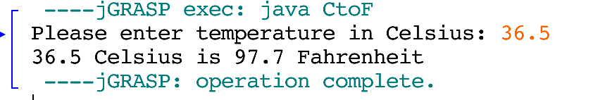

**Test 2.**

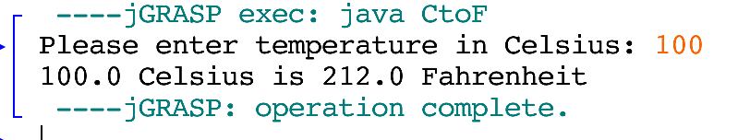

**[For Exercises 2 - 5 define and call a method]**

**Exercise 2.** Define and test a method to print a triangle as follows (use any loop to print the pattern).

*  
 **  
 ***  
 ****  
 *****

public static void ascendingTriangle(){  
 for(int i=1; i<=5; i++){ //counts for 5 intervals  
 for(int j=5; j>=0; j--){ //counts for 5 intervals  
 if(j >= i) //if j is greater than i, place a space  
 System.out.print(" ");  
 else //other wise make "*" shape  
 System.out.print("*");  
 }  
 System.out.println(); //prints space  
 }  
 }

**Test 1.**

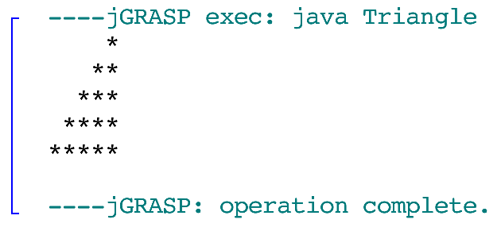

Define a second method to print a triangle as follows.

*****  
 ****  
 ***  
 **  
 *

public static void descendingTriangle(){  
 for(int i=1; i<=5; i++){//counts for 5 intervals

System.out.print(" ");  
 for(int j=5; j>=i; j--)//has intervals while j is >= to i  
 System.out.print("*");  
 System.out.println();  
 }  
 }

**Test 1.**

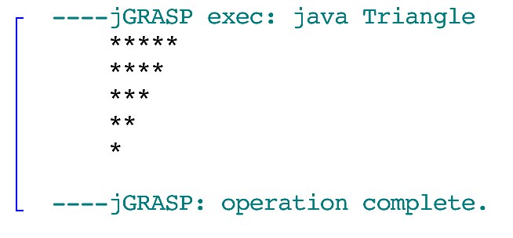

Using these methods with a for-loop print the following pattern.

*  
 **  
 ***  
 ****  
 *****

*****  
 ****  
 ***  
 **  
 *

*  
 **  
 ***  
 ****  
 *****

*****  
 ****  
 ***  
 **  
 *

*  
 **  
 ***  
 ****  
 *****

*****  
 ****  
 ***  
 **  
 *

*  
 **  
 ***  
 ****  
 *****

*****  
 ****  
 ***  
 **  
 *

**Include the program and 1 test case**

**Program:**

public class Triangle{  
 public static void main(String[] args){  
 for(int i = 1; i<=8; i++){//8 interations  
 if(i%2 != 0) //if 8 is divisible by 2, make ascending triangle  
 ascendingTriangle();  
 else  
 descendingTriangle();// otherwise, descending  
 }  
 }  
   
 public static void ascendingTriangle(){  
 for(int i=1; i<=5; i++){ //counts for 5 intervals  
 for(int j=5; j>=0; j--){ //counts for 5 intervals  
 if(j >= i) //if j is greater than i, place a space  
 System.out.print(" ");  
 else //other wise make "*" shape  
 System.out.print("*");  
 }  
 System.out.println(); //prints space  
 }  
 }  
   
 public static void descendingTriangle(){  
 for(int i=1; i<=5; i++){//counts for 5 intervals  
 System.out.print(" ");  
 for(int j=5; j>=i; j--)//has intervals while j is >= to i  
 System.out.print("*");  
 System.out.println();  
 }  
 }  
}

**Test 1.**

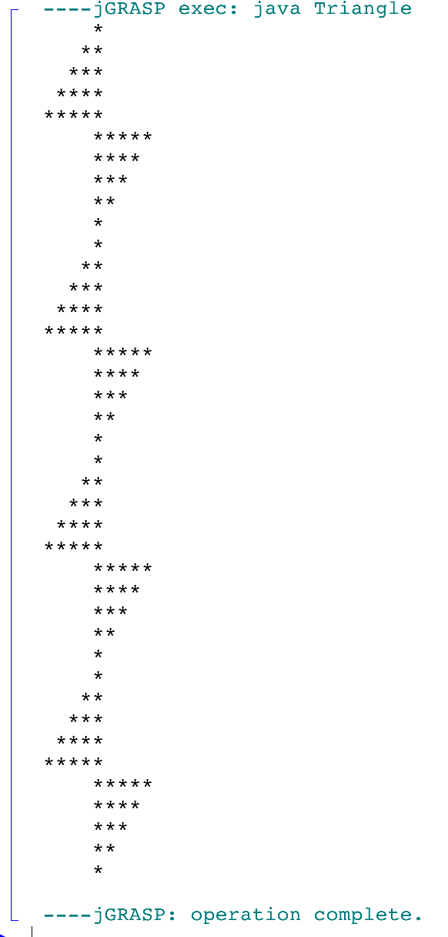

**Exercise 3.** Write a program that uses a Scanner to read a word (of any length) and a number. The program will then call a method call printWord that will take in the word and number as parameters and will print the word all in uppercase letters on the inputted number of lines (using a **for loop**):

**Include the program and 2 test cases**

**Program:**

import java.util.Scanner;  
  
public class Lab7E3{  
 public static void main(String[] args){  
 String word = "";  
 int num = 0;  
 Scanner input = new Scanner(System.in);  
 /*The following prompts user for word and number,  
 assigns them to 'word' and 'num' */  
 System.out.print("Please type a word: ");  
 word = input.nextLine();  
 System.out.print("Please type a number: ");  
 num = input.nextInt();  
   
 System.out.println();  
   
 printWord(word, num);//calls printWord methof  
 }  
   
 public static void printWord(String word, int num){  
 for(int i=0; i<num; i++) //has 'num' interations  
 //the '%S converts word to capitalized form  
 System.out.printf("%S\n", word);   
 }  
}

**Test 1.**

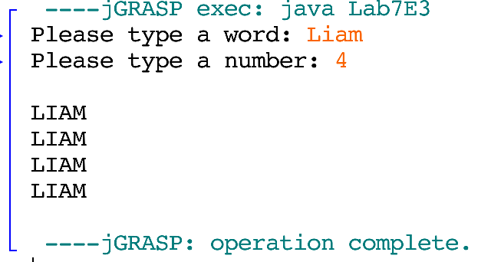

**Test 2.**

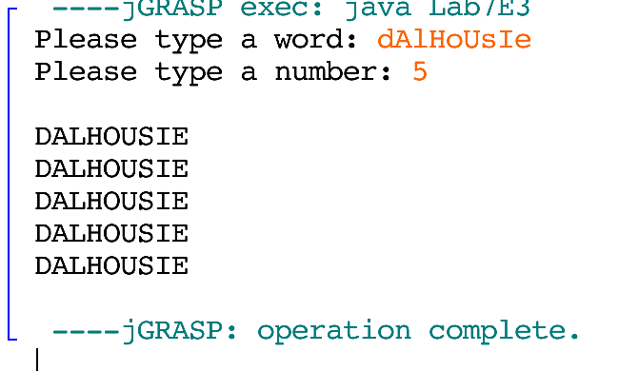

**Exercise 4.** Write a program that uses a Scanner to read a word. Then define and use a method called checkString that will take in the word as a parameter and check whether the string begins and ends with the same letter and prints the result. The program treats lower and uppercase letters as equivalent.

Type a string: abba

abba begins and ends with the same letter

**Include the program and 2 test cases**

**Program:**

import java.util.Scanner;  
  
public class FirstLetterLastLetter{  
 public static void main(String[] args){  
 String word = "";  
 Scanner input = new Scanner(System.in);  
 //prompts user for string, assigns to 'word'  
 System.out.print("Type a string: ");  
 word = input.nextLine();  
   
 checkString(word); //calls checkString method  
 }  
   
 public static void checkString(String word){  
 //program is not case sensitive, so change word to caps  
 String wordCap = word.toUpperCase();  
   
 /*Program checks to see if the first character is the last   
 character or wordCap. It does this by using wordCap.length()  
 -1, because if you do not subtract 1 it will cause an error  
 as it will be out of range. */  
   
 if(wordCap.charAt(0) == wordCap.charAt(wordCap.length()-1)){  
 System.out.print(word + " begins and ends with " +  
 "the same letter");  
 }  
 else{  
 System.out.print(word + " does not begin and end " +  
 "with the same letter");  
 }  
 }  
}

**Both tests:**

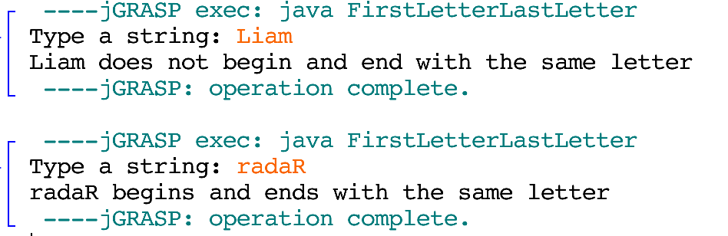

**Exercise 5.** Write a program that uses a Scanner to read an int and two chars. The program will then call a method called printChars. Define and use the method printChars that will take in the two chars and the integer as parameters and will then print the following pattern.

**Include the program and 2 test cases**

**Program:**

import java.util.Scanner;  
  
public class CharPrinter{  
 public static void main(String[] args){  
 int num = 0;  
 Scanner input = new Scanner(System.in);  
 //Prompts for & assigns int & char variables  
 System.out.print("Enter a number: ");  
 num = input.nextInt();   
 System.out.print("Enter a char: ");  
 char ch1 = input.next().charAt(0);  
 System.out.print("Enter a char: ");  
 char ch2 = input.next().charAt(0);  
 printChars(num, ch1, ch2);//calls printChars methof  
 }  
   
 public static void printChars(int num, char ch1, char ch2){  
 /*outside for loop prints while i is less than or equal to  
 num. It must be 'or equal to' so that it will print the   
 last line of entirely 'ch2'*/  
 for(int i=0; i<=num; i++){  
 /*will print a symbol for 'num' value of times.  
 if j (num) is greater than i, it will print 'ch1',  
 otherwise ch2. */  
 for(int j=num; j>0; j--){  
 if(j>i)  
 System.out.print(ch1);  
 else  
 System.out.print(ch2);  
 }  
 System.out.println(); //prints line  
 }  
 }  
}

**Test 1.**

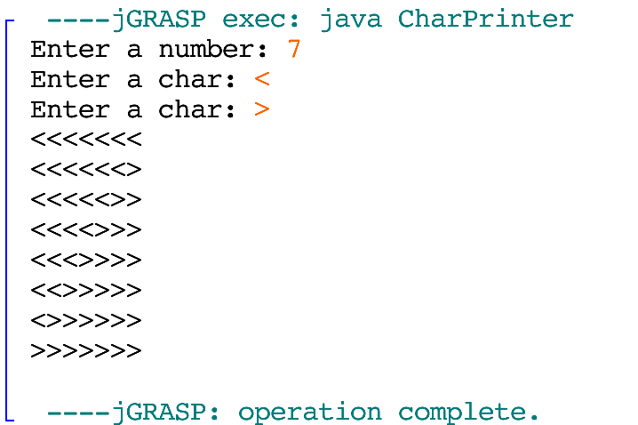

**Test 2.**

